CodeGuide

SRS

Introduced by TeamG11

|  |  |  |  |  |
| --- | --- | --- | --- | --- |
| Version | Written by | Reviewed by | Approved by | Date |
| 1 | Omar Alam | Mark Youssef | Omar Hesham | 1-12-2018 |
| 2 | Karem Salah | Omar Nasr | Martin Joseph | 6-12-2018 |
| 3 | Omar Alam | Omar Nasr | Fatma Abdel Moneim | 7-12-2018 |

# Table of Contents

Table of Contents 2

1. Introduction 4

1.1. Executive Summary 4

1.2. Document Overview 4

1.3. References 4

2. System Description 5

2.1. Introduction 5

2.2. Users 5

2.3. Modules 6

Context Diagram for CodeGuide: 7

3. System users 8

3.1. Administrator 8

3.2. Visitor 8

3.3. User 8

3.4. Specialist 9

4. System Modules 10

4.1. Post 10

4.1.1. Context diagram 11

4.1.2. Activity diagram 12

4.1.3. State machine diagram 13

4.1.3 Data flow diagram 14

4.2. Groups 15

4.2.1 Context diagram 16

4.2.2. Activity diagram 17

4.2.3. State machine diagram 18

4.2.4. Data flow diagram 18

4.3. Specialist 19

4.3.1. Context diagram 19

4.3.2. Activity diagram 20

4.3.3. State machine diagram 21

4.3.4. Data flow diagram 21

4.4 User 22

4.4.1. Context diagram 22

4.4.2. Activity diagram 23

5. System functions 24

Module functions 24

5.1. Sign up 24

5.2. Log in 24

5.3. Ask a question 25

5.4. Answer 25

5.5. View all questions 26

5.6. View all answers 26

5.7. Search 26

5.8. Bookmark 27

5.9. Rate 27

5.10. Report a question 27

5.11. Create group 28

5.12. View profile page 28

6. System Models 29

6.1. Use case diagrams 29

6.2. Sequence diagrams 30

7. Non-Functional Requirements 32

7.1. Security 32

7.2. Ethical 32

8. System Interfaces 33

8.1. Home Page 33

8.2. Sign-up Page 33

8.3. About us Page 34

8.4. Log-in page 34

8.5. After login page (view questions) 35

8.6. Group page: 35

8.7. Ask a question 36

8.8. Question page (with commenting) 36

8.9. Profile page 37

# Introduction

## Executive Summary

CodeGuide is a website service to everyone, especially people who Interested in programming. they face many problems while coding because they don’t find the best function which executes Their target perfectly.

it should offer millions of questions and answers about actual problems facing some users as a large question bank will be formed and it will increase incrementally by users’ interaction.

it should offer the best online courses related to certain languages they want to learn and online problem solving tests so users can improve their skills.

It should provide experts’ answers for questions asked by users using service” Ask a specialist”.

It allows users to create groups where they can discuss certain problem or work on a certain project

## Document Overview

This document introduce CodeGuide study plan.

It introduce general description, Graphical description of the system, Technical description.

## References

1. <https://en.wikipedia.org/wiki/Stack_Overflow>
2. <https://stackoverflow.com/tour>

1. <https://askwonder.com/q/what-are-the-key-features-that-have-led-to-stack-overflows-success-in-crowd-sourcing-high-quality-57932bfd411caa2500ea4f78>
2. <https://en.wikipedia.org/wiki/Quora>

# System Description

## Introduction

CodeGuide is a website service to everyone, especially people who Interested in programming. they face many problems while coding because they don’t find the best function which executes Their target perfectly.

it should offer millions of questions and answers about actual problems facing some users as a large question bank will be formed and it will increase incrementally by users’ interaction.

it should offer the best online courses related to certain languages they want to learn and online problem solving tests so users can improve their skills.

It should provide experts’ answers for questions asked by users using service” Ask a specialist”.

It allows users to create groups where they can discuss certain problem or work on a certain project.

## Users

|  |  |
| --- | --- |
| Administrator | They are one of the system users, They are actually the site managers and supervisors |
| Users | They are either REGULAR users or PREMIUM users.  Each have different options discussed below |
| Visitors | Unregistered users |
| Specialists | They are very special users that have professional account, they get paid for answering questions |

## Modules

|  |  |
| --- | --- |
| Post | Posts in CodeGuide is simply questions asked by users about the problem faced them in programing |
| Group | These groups are a tighter area for a group of users where they can communicate privately and easier than in public. |
| Specialist | Each specialist should have a professional account.  Specialist will get paid according to its rates (more requests he gets more money he gains). |
| User | This Module contain all information about users of CodeGuide, including their every contribute they have done on CodeGuide |

## 

## Context Diagram for CodeGuide:

**StackOver  
Flow**

**Online Course** **Sites**

Exterior

Interior

**Credit   
Agencies**

**visitor**

**CodeGuide  
System**

# System users

## Administrator

The admin is the coordinator who manages the content of website and maintains its design.

#### Activities

1. He is responsible for updating the design of website
2. He keeps website backed up and fully function
3. He is responsible for maintenance of the website
4. He can ban users who break website policies
5. He can approve users that sign up with specialist accounts according to their technical skills and programming languages they are expert in.

## Visitor

The visitor is the user that does not have an account in the website but he still can access some features when he opens the CodeGuide.

#### Activities

1. He can search for his questions in the search engine.
2. He can see links of online courses
3. He can’t write posts or comments

## User

The user has an account on the website and sign in with it in CodeGuide, he get benefit of more features than visitor.

#### Activities

1. Register as “member”.
2. Post a question and write comments.
3. Show his questions or all questions on the site.
4. Show notifications icon on navigation bar –where he can follow his questions updates & any updates in groups-.
5. Create & join groups to share knowledge with others and gain the experience of teamwork.
6. User can connect to the online courses.
7. User can use a paid service to ask a specialist about his problem.
8. Users can give rating for the comments on the posts
9. Users can bookmark the important questions

## Specialist

He signed up in CodeGuide by creating a specialist account.

He must provide in his account his technical skills and programming languages which he is expert in it.

This account must be approved by admins first.

Once his account has been approved the premium users can get him.

#### Activities

1. Register as “specialist”.
2. Answer questions that are assigned to him by premium users.
3. He can put his CV in website and also his answers are rated by premium users and according to his rates he will get paid.

# 4. System Modules

* In Order to simplify recognition of the system we divided it into many Modules as the following:
* Modules: that interact with system directly

1. Post Module

2. Specialist Module

3. Group Module

4. User Module

## 4.1. Post

User can interact with community by Posting his Question

#### A) Questions and Comments

User can write his question or reply to others questions by commenting.

- Some of its features are listed below:

1. User can upload images & files related to his question.

2. User can include links.

3. Posts can be written in different fonts, styles, sizes & colours.

4. User can write the code that he wants to ask about in a specific area.

5. User can use tags to relate his question with specific topic.

6. Number of characters that user can type are limited to 600 characters.

#### B) Language

The user decide which language he want to ask the question in or if he asking a general question.

User can show Posts related to certain language by filtering

All questions are tagged with their subject areas. Each can have up to 5 tags, since a question might be related to several subjects.

Click any tag to see a list of questions with that tag, or go to the tag list to browse for topics that interest you.

#### C) Rates

The system enables evaluation for every post and question. The evaluation based on the quality of the generated questions.

System trust the user’s ability to do evaluation. Users may report the question or rate the answers.

By time the rating helps other user to find most high rated answers. That helps users to find their answers easily.

- Its Features:

1. you can bookmark any question.

2. The comments are rated by others and the answer that has the best rating will be marked as the best solution.

3. there is only positive rating through a blue ‘helpful’ button beside the comment.

4. Best rated comment will be put below the question so that other users searching for the same question can reach the best answer easily.

### 4.1.1. Context diagram

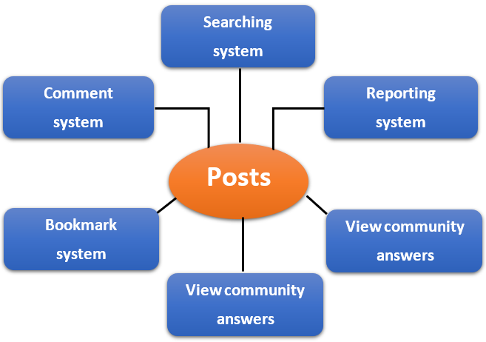

### 

### 4.1.2. Activity diagram

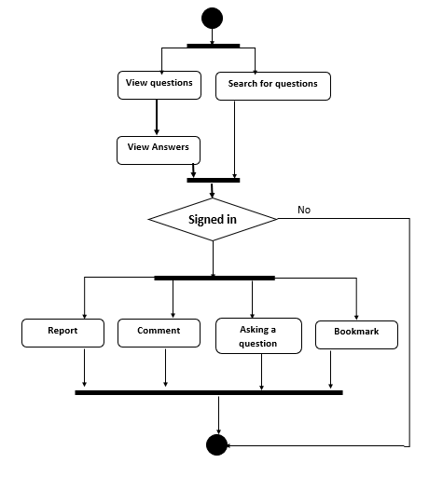

### 4.1.3. State machine diagram

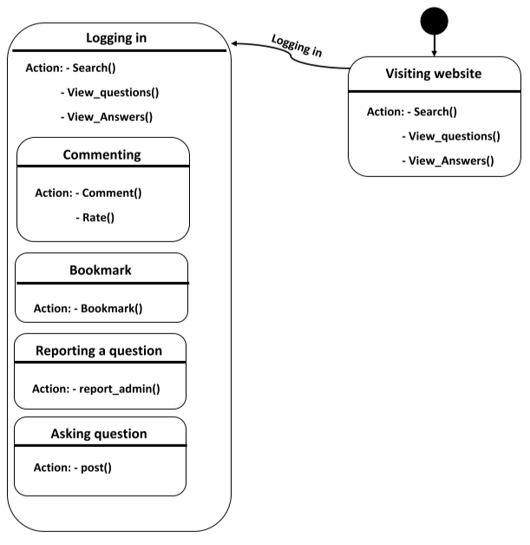

### 4.1.3 Data flow diagram

#### 4.1.3.1. Viewing posts

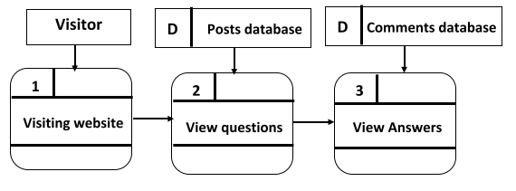

#### 4.1.3.2. Posting

## 

## 4.2. Groups

Groups is a section in the website where users can learn, communicate and work on project together so that users can learn how to work in a team by the interactions between them.

Every group should have a main theme, idea or project. The users can add questions and set the expected answer through polls system. The admin user can control the group and who will enter that group.

The group specifications as follows

* + System provide any number of questions in the group.
  + System supports polls for users to help discussion.
  + The polls are created by any users.
  + Users can rate the questions and answers.
  + Users can’t access the group project question or posts unless they apply for it.

Groups can be created for multiple purposes such as Arranging and following projects and discussing certain ideas in specific field of coding.

#### A) Members

The members of group either be instructors or students, it could have one or more specialist.

#### B) Posts

The posts created in this group will be exclusive to this group.

Nobody outside this group can access this posts

#### C) Polls

Admin of each group can make a poll for his students about the incoming events.

Students or members of the group could vote to this polls.

### 

### 4.2.1 Context diagram

### 

### 4.2.2. Activity diagram

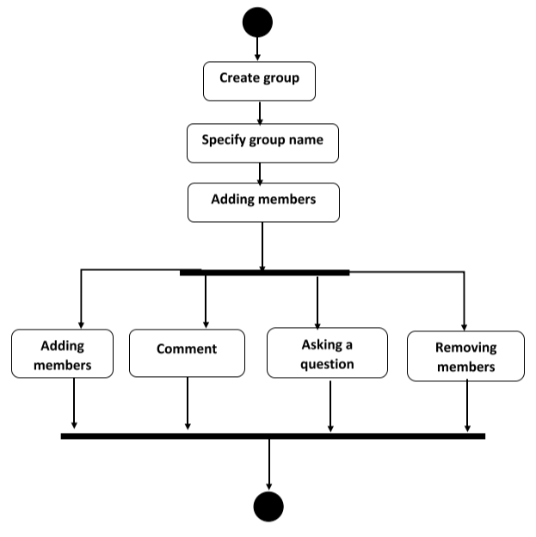

### 4.2.3. State machine diagram

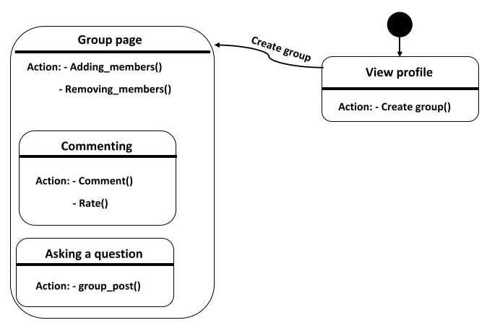

### 4.2.4. Data flow diagram

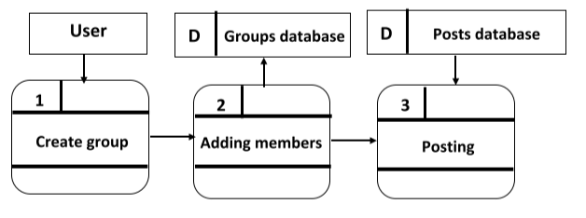

## 4.3. Specialist

This module provides specialist to sign up on site and answer the question asked by users for money and users can join in group with him and be in continuous contact with him.

User’s questions appear on the home page for the specialist after signing in and he can show all users’ questions.

Specialists can create groups with users to make a specific project where users can benefit from this group.

#### A. Technical profile

On the specialist profile there will be:

· His rating which the users gave to him.

· The number of questions he had answered.

· It has his technical skills and languages that he domains it.

#### B. Income

Each Specialist according to his rates will be assigned to level of specialist and each level has it profit for answering the questions.

### 4.3.1. Context diagram

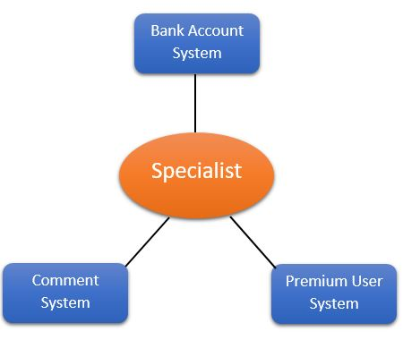

### 4.3.2. Activity diagram

## 

### 4.3.3. State machine diagram

### 4.3.4. Data flow diagram

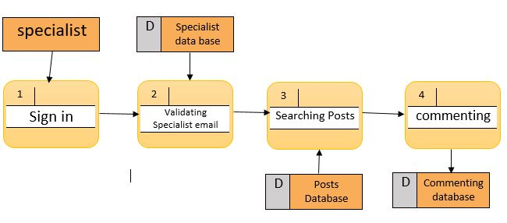

## 4.4 User

#### A. Profile

Profile page includes basic information of the user:

1. Username (should be unique).

2. Password (should not be less than 12 characters and include at least

one letter).

3. Profile Picture

4. It contains his posts.

5. A tab including all the website questions.

6. A dropdown box for notifications.

#### B. User Should

1. Login first in order to post his question or reply to others questions.

2. Make his question specific & clear as much as possible.

3. Help people with their problems so that others can help you with your problems.

4. Consider that the number of characters does not exceed the limit.

### 4.4.1. Context diagram

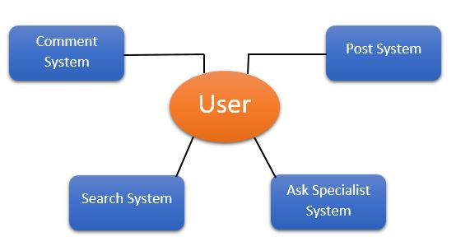

### 4.4.2. Activity diagram

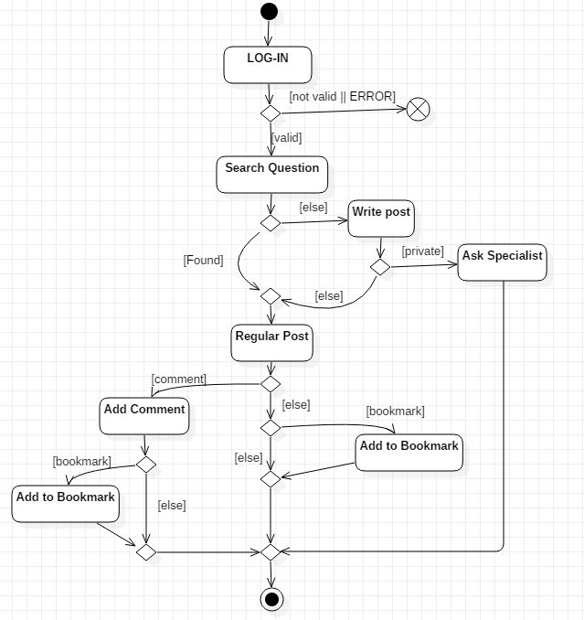

# 5. System functions

## Module functions

### Sign up

|  |  |
| --- | --- |
| Code | [M3/M4-FR-N1] “User module – Specialist module” |
| Description | - Allows user to sign up to the system to access its  features  - e.g.: ask, answer, creating groups |
| Input | * First name * Last name * E-mail * password |
| Output | Be logged in |
| Pre-conditions | - Valid e-mail |
| Post-conditions | - e-mail must match password of the user to use it  to log in to the system later  - e-mails shouldn’t be duplicated |

### Log in

|  |  |
| --- | --- |
| Code | [M3/M4-FR-N2] “User module – Specialist module” |
| Description | - Logging to the system to access its features  - e.g.: ask, answer, creating groups |
| Input | E-mail  password |
| Output | Be logged into home page |
| Pre-conditions | - e-mail matches the password entered by the user |
| Post-conditions | - No post conditions |

### Ask a question

|  |  |
| --- | --- |
| Code | [M1/M4-FR-N3] Post module – User module |
| Description | - Posts in CodeGuide is simply questions asked by users about the problem faced them in programming. |
| Input | Programming language  Question text  Choose between asking community or specialist |
| Output | Your question will appear on home page and stored in the database |
| Pre-conditions | - User must be signed in  - Asking specialist recommends that you have premium account.  - number of characters of the question shouldn’t exceed 600 characters. |
| Post-conditions | - Your post must be ethical in order not to be removed by the admin. |

### Answer

|  |  |
| --- | --- |
| Code | [M4/M1-FR-N4] User module – Post module |
| Description | - All Users can comment on any post and specialists can comment on premium users’ questions |
| Input | Comment text  Files |
| Output | Your answer will appear beyond the post and stored in the database |
| Pre-conditions | - User must be signed in  - number of characters of the question shouldn’t exceed 600 characters. |
| Post-conditions | - Your answer must be ethical in order not to be removed by the admin. |

### View all questions

|  |  |
| --- | --- |
| Code | [M3/M4-FR-N5]  “User module – Specialist module” |
| Description | - View all questions on home page |
| Input | Filtered language |
| Output | Questions will appear giving you functionality to comment on them, view community answers, bookmark them. |
| Pre-conditions | User must be signed in to comment or bookmark a question |
| Post-conditions | No post conditions |

### View all answers

|  |  |
| --- | --- |
| Code | [M4-FR-N6] User module |
| Description | - View all answers of certain post on clicking of answers button on the post. |
| Input | The chosen post |
| Output | Answers will appear giving you functionality to rate them, view community answers. |
| Pre-conditions | - User must be signed in to rate a specific answer. |
| Post-conditions | No post conditions |

### Search

|  |  |
| --- | --- |
| Code | [M1-FR-N7] “Post module”. |
| Description | - Search all questions on database |
| Input | Enter your query in search bar in navigation bar |
| Output | All questions related to your query will appear in on home page |
| Pre-conditions | - No pre-conditions |
| Post-conditions | No post-conditions |

### Bookmark

|  |  |
| --- | --- |
| Code | [M1-FR-N8] “Post module” |
| Description | - this functionality enables you to save a post asked by the others to be able to view it later |
| Input | Clicking on bookmark button on the post |
| Output | The post will be saved in bookmarks list. |
| Pre-conditions | - You must be signed in |
| Post-conditions | No post-conditions |

### Rate

|  |  |
| --- | --- |
| Code | [M1-FR-N9] “Post module” |
| Description | - This functionality enables you to rate a specific answer on certain post with helpful, so that the answer with high rating will appear at the top of the answers on that post |
| Input | Clicking on helpful button on the answer |
| Output | The answer will appear at the top. |
| Pre-conditions | - You must be signed in |
| Post-conditions | No post-conditions |

### Report a question

|  |  |
| --- | --- |
| Code | [M1-FR-N10] “Post module” |
| Description | - User can report a question to the admin, so that the admin will remove it from the database directly. |
| Input | Clicking on report button on the post. |
| Output | The post will be reported to the admin. |
| Pre-conditions | - You must be signed in. |
| Post-conditions | No post-conditions |

### Create group

|  |  |
| --- | --- |
| Code | [M2-FR-N11] Group module |
| Description | - User can create groups with other colleagues in order to share their ideas or questions with each other.  -The admin of the group will give the group a name and add members to it. |
| Input | Click on create group button on your profile page and search for members. |
| Output | New group will be created and will appear on users’ group list. |
| Pre-conditions | - You must be signed in. |
| Post-conditions | Groups must be accessed by its members only. |

### View profile page

|  |  |
| --- | --- |
| Code | [M3/M4-FR-N12] User module – Specialist module |
| Description | - User can view his/her profile, containing all posts asked by him or her , viewing all the groups created by him or her, bookmarks of others’ posts. |
| Input | Click on view profile icon on the nav bar. |
| Output | Viewing user’s posts, groups, bookmarks. |
| Pre-conditions | - You must be signed in. |
| Post-conditions | No post-conditions |

# 6. System Models

## 6.1. Use case diagrams

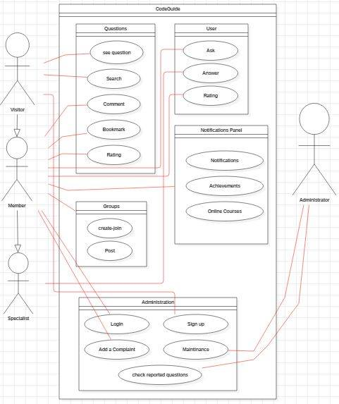

## 6.2. Sequence diagrams

### 6.2.1. Specialist

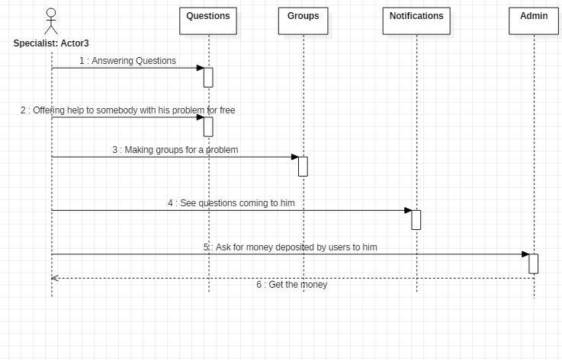

### https://scontent.faly1-2.fna.fbcdn.net/v/t1.15752-9/46930734_585345128575714_6597656059756675072_n.jpg?_nc_cat=109&_nc_ht=scontent.faly1-2.fna&oh=62e02fb446dff8a675e50e5b2a4fb705&oe=5C729511 6.2.2. Visitor

### 6.2.3. Member

# 7. Non-Functional Requirements

## 7.1. Security

Systems provides security through various levels. Keeping privacy and contents safe as possible.

* User’s password encryption.
* Only user can view his profile and edit it.
* Users need to ask permission to join a group and see its content.
* Encryption for banking related to “ask specialist”.

## 7.2. Ethical

* System removes inappropriate Posts.
* System removes Post that violent the copyright

# 8. System Interfaces

## 8.1. Home Page

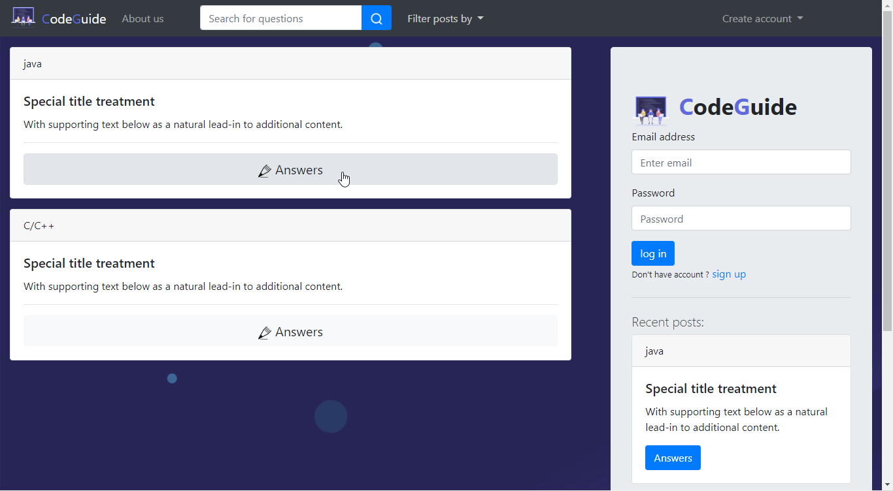

## 8.2. Sign-up Page

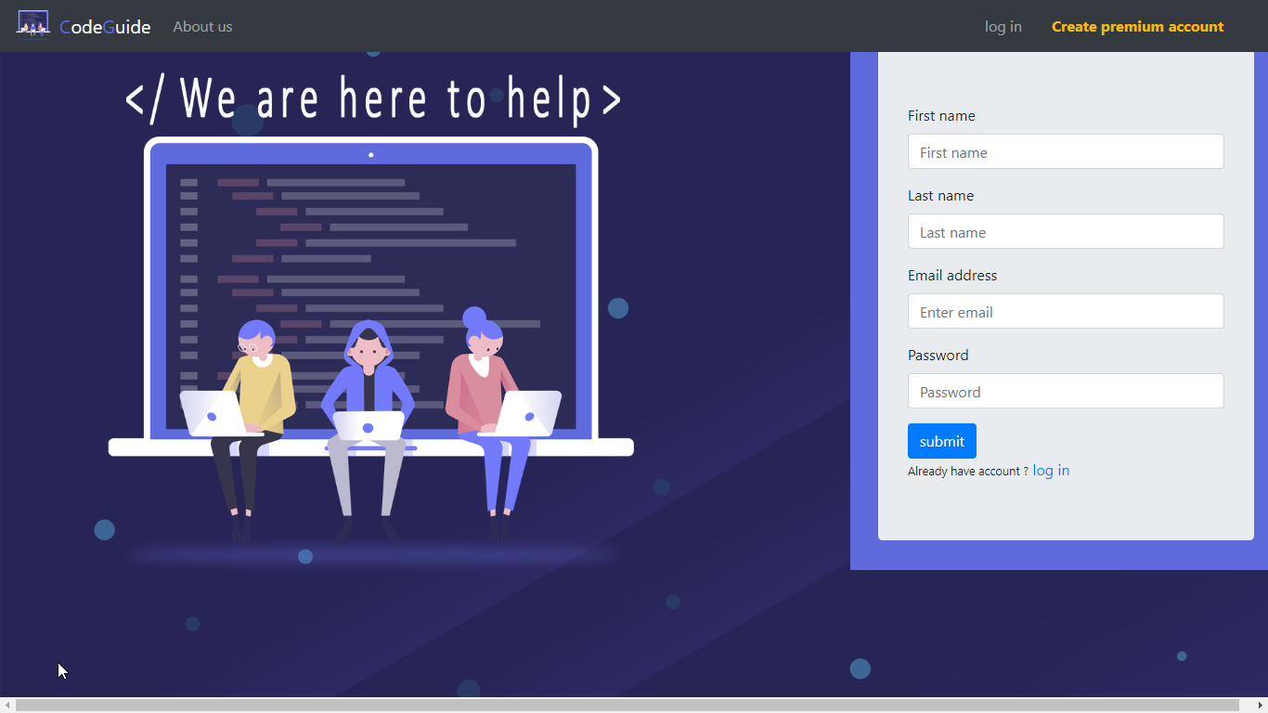

## 8.3. About us Page

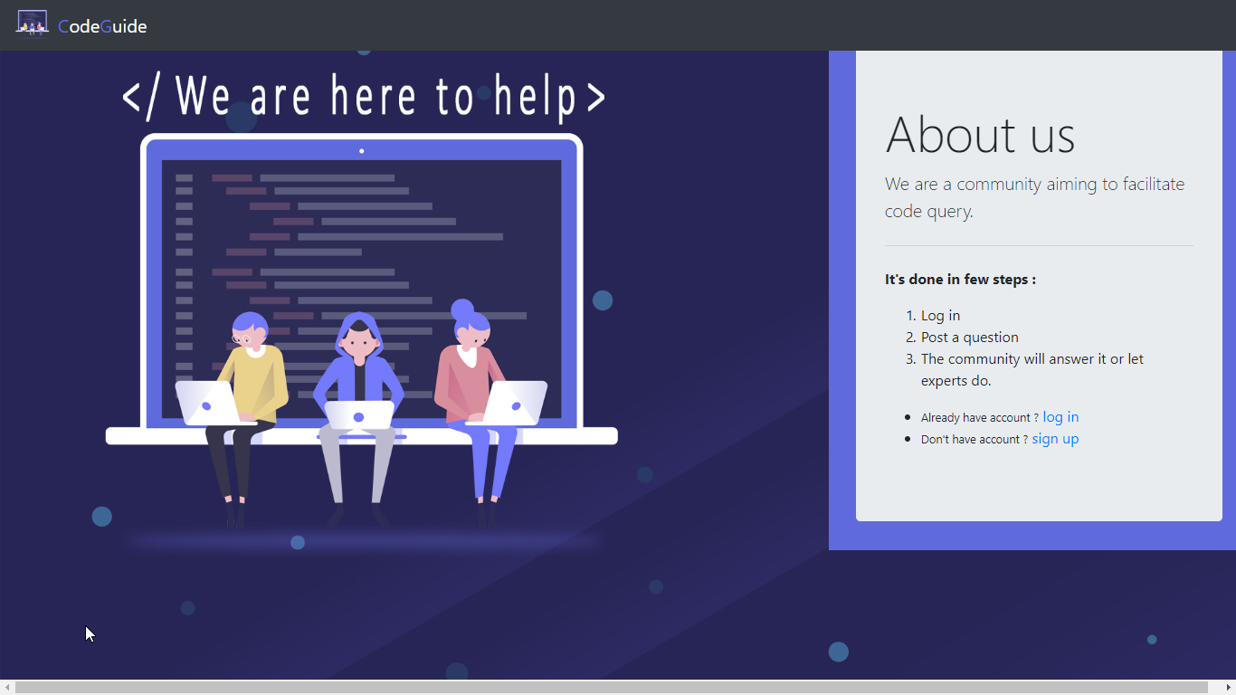

## 8.4. Log-in page

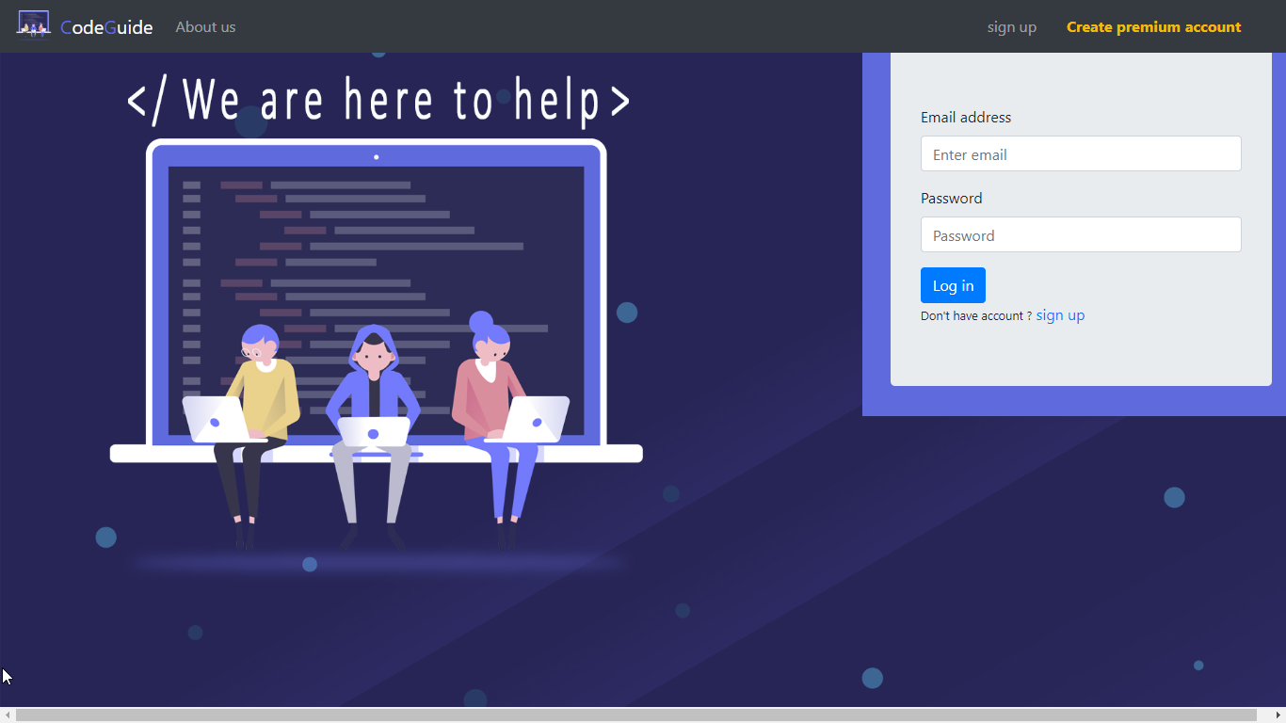

## 8.5. After login page (view questions)

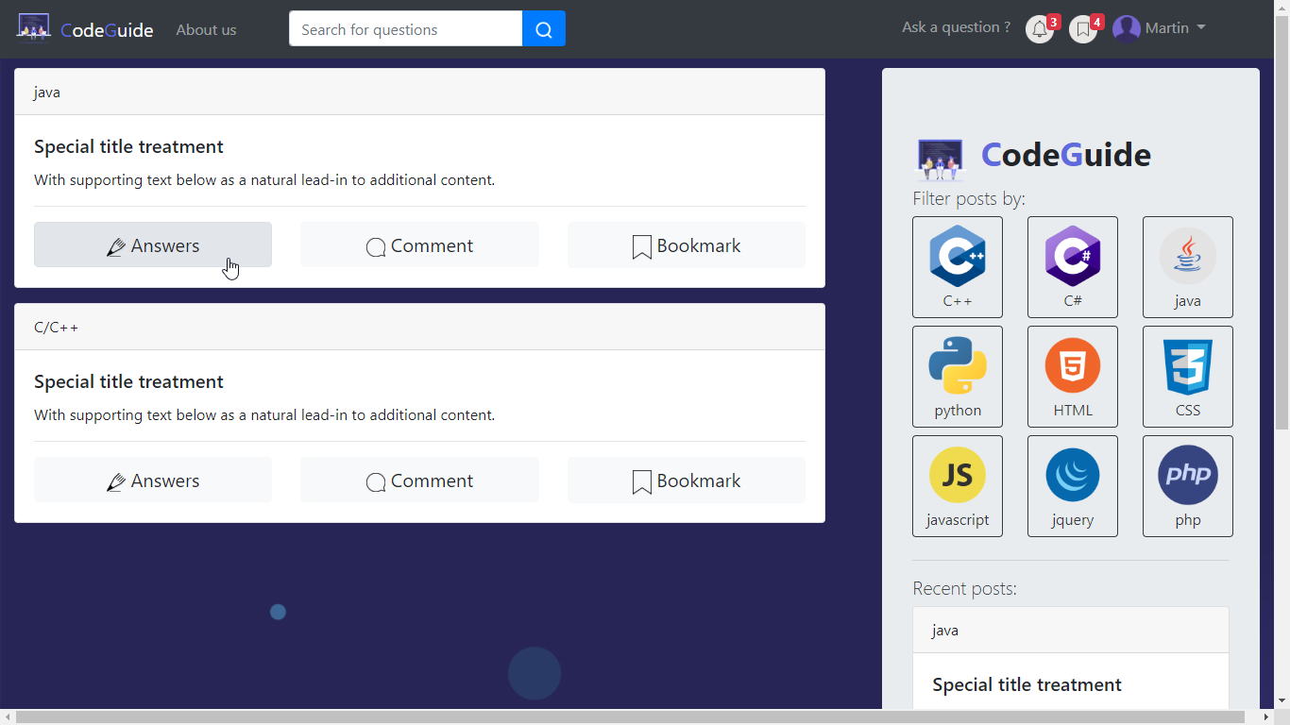

## 8.6. Group page:

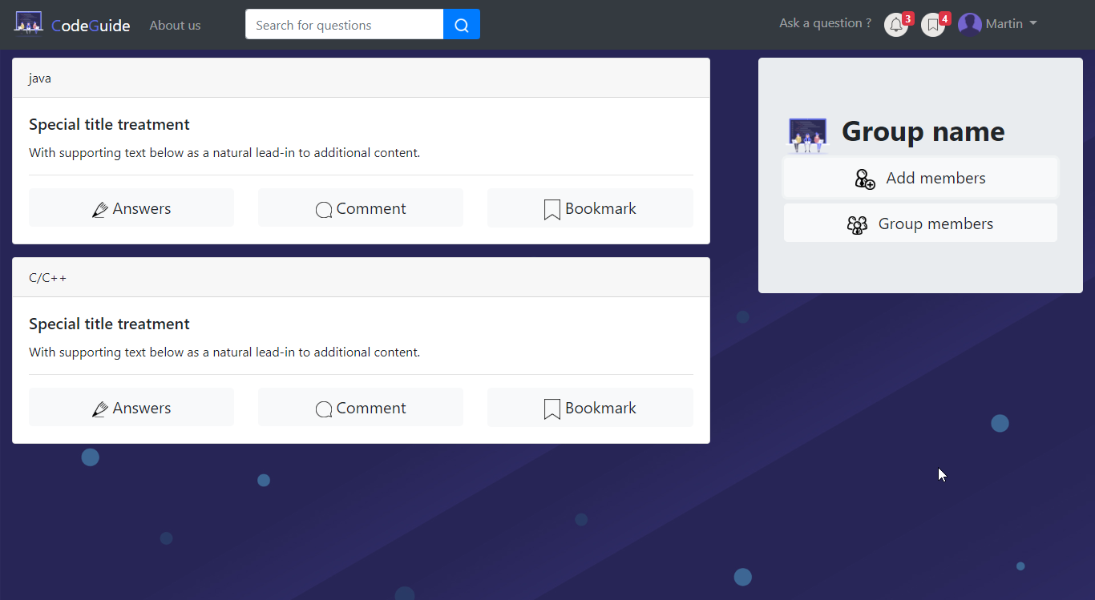

## 8.7. Ask a question

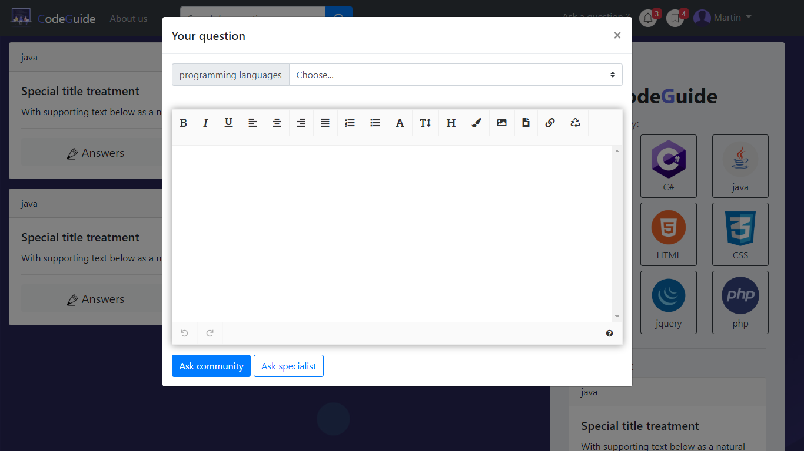

## 8.8. Question page (with commenting)

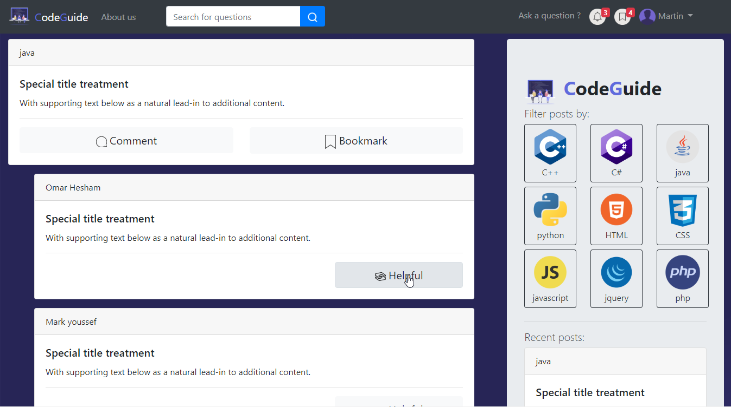

## 8.9. Profile page

